Raspberry Pi – RetroPie Emulator

Jonathan Franck

Objective: The purpose of this project is to turn your Raspberry Pi into retro video game emulator called a RetroPie.

# What You Need

You will need a Raspberry Pi (model 3 or newer is recommended) with an SD card, a monitor/TV with an HDMI cable, some sort of input device (mouse/keyboard/controller), another computer, and a USB drive. It is also highly recommended that you have a fan and heat syncs, because running an emulator can be very taxing on your Raspberry Pi.

# Step 1: Software

Download the RetroPie Repository, on your computer, from GitHub (<https://www.github.com/retropie/retropie-setup/releases/latest>), and make sure you install the correct version for your Pi. The version for the Raspberry Pi 3 and newer (which is recommended for this project) is circled below.

You will also need to download and install an application from Balena, called Etcher (<https://www.balena.io/etcher>)

# Step 2: Installing RetroPie

IMPORTANT NOTE: This step will erase all previous data from your SD card

Once you have installed Etcher, run it. It will ask you to select and image and a drive. For the first, select the RetroPie repository that you just downloaded. For the drive, it may automatically select your SD card once it is in your computer, otherwise select the SD card you plan to use (make sure it is the correct one!). Once you have done this click “Flash” and it will begin.

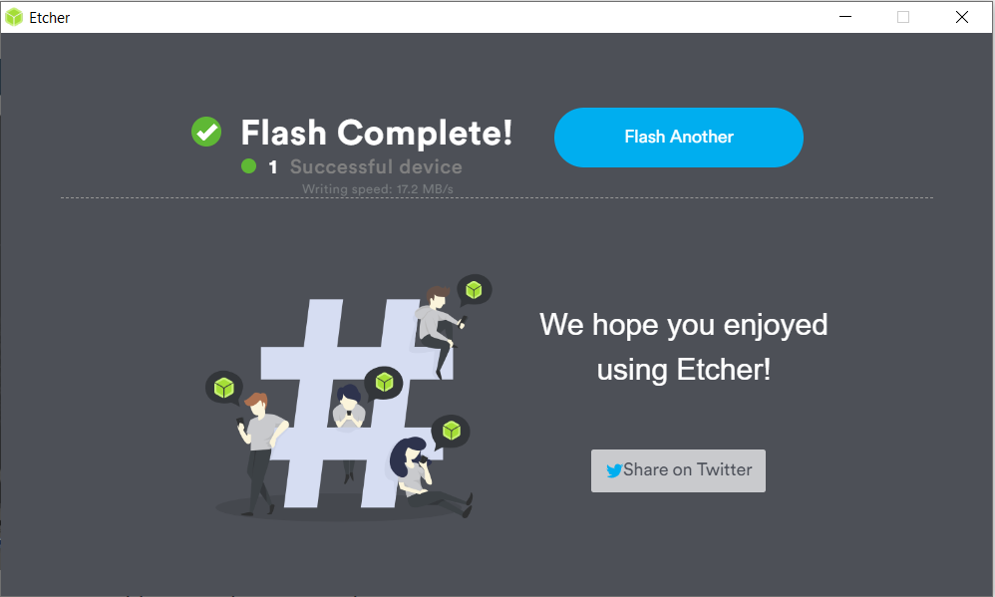

(this is the screen you should see when it is done)

# Step 3: Configure Your RetroPie

Insert the SD card into your Pi and boot it up. Upon the first startup, it will ask you to configure an input device for the games. I used a keyboard and mapped the buttons to easy to remember keys (like the arrows, spacebar, enter, and the number pad).

Now your RetroPie is ready to go… now you just need games

# Step 4: Downloading ROMS on a USB

The process of downloading the ROMS is actually the longest part of the entire project, but that doesn’t mean it is difficult. The first thing you have to do is create a file on your USB named “retropie”. This is a directory that the RetroPie will automatically recognize. Now just plug it into the Pi, and wait a few minutes to configure (if your drive has a light, wait for it to stop blinking, otherwise give it at least 2-3 mins).

When it is done, put it back into your computer. It should have three new directories: BIOS, config, and roms. Inside the roms folder, there should be a bunch of files, one for each emulator.

Now you can download ROMs (read-only-memory, aka the game files) from online and copy them to the folder corresponding to the console it will be emulated on. There are plenty of sites that offer free ROMs online, but the one I used was [wowroms.com](https://wowroms.com/)

Make sure that you copy them to the right folder (all of mine were games for the NES) and note that you don’t have to extract any of them either.

# Step 5: Copy games to the RetroPie

Once you have all the ROMs for every game you want, remove your USB and insert in into the RetroPie. Again wait for the light to stop blinking on the flash drive, or a few minutes (several if you downloaded a bunch of games). Once it is done, go to the main menu, select quit, and then restart EmulationStation. This causes the RetroPie to refresh and load up all of the new ROMs you downloaded.

After it restarts, your new emulators should show up with all of the games you installed for them. Enjoy!

(I tested Super Mario Bros 3, and it worked great!)